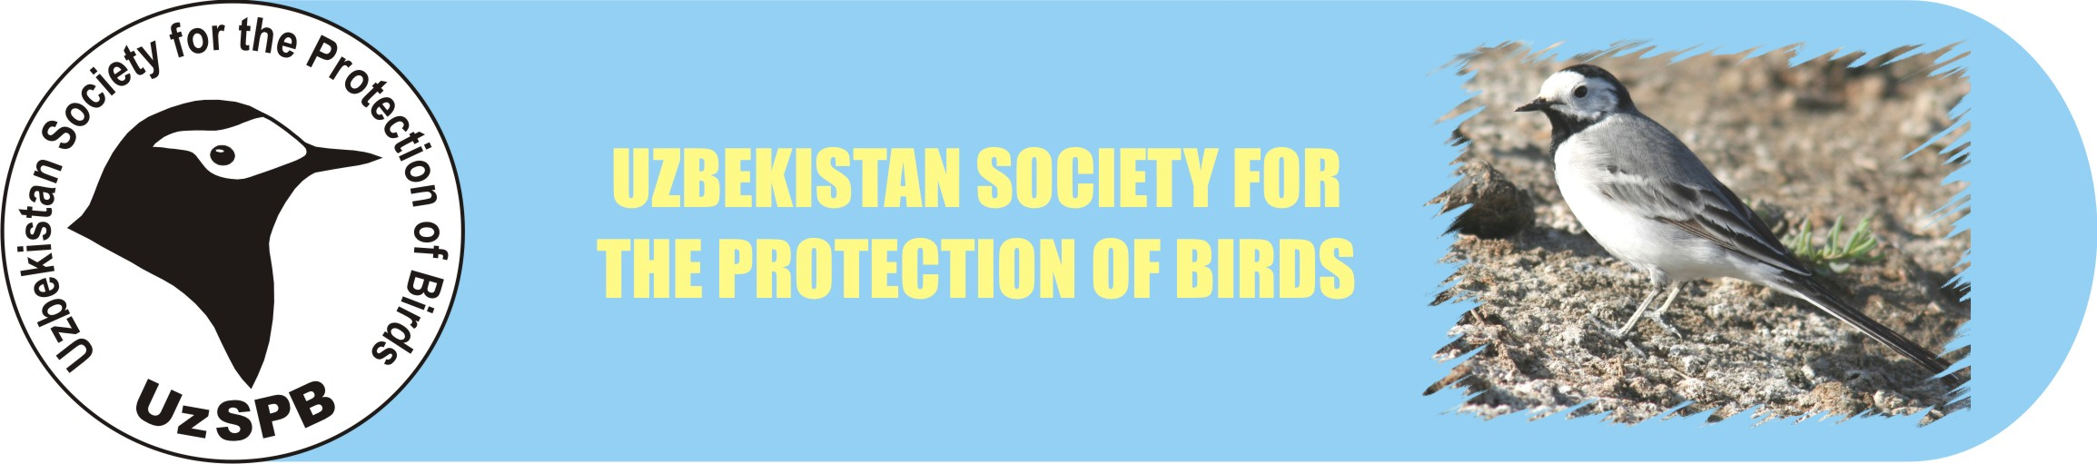

To Executive Directorate
of Uzbekistan Society for the Protection of Birds

from_________________________________

REQUEST

I ask you to affiliate me with Uzbekistan Society for the Protection of Birds (UzSPB). I familiarized myself with Statue of UzSPB.

Signature_________________

UzSPB MEMBERSHIP FORM

- Full name __________________________________________________________________
- Date of birth ________________________________________________________________
- Passport data (passport number, date of issue) ______________________________________
___________________________________________________________________________
4. Address_____________________________________________________________________
5. Telephone, e-mail_____________________________________________________________
- Profession (study)_____________________________________________________________
- Position and academic degree (for students indicate year and chair) _____________________
___________________________________________________________________________
- Official address and telephone number____________________________________________
___________________________________________________________________________
- Who proposed you to become UzSPB member? ____________________________________
- Please underline fields of your interests:
а. professional – scientific research;
б. nature-conservative profession or public work;
в. bird watching (hobby);
г. photography of birds;
д. breeding of birds;
е. something else _____________________________________________________________
12. In which actions of UzSPB you would like to take part? ______________________________
______________________________________________________________________________________________________________________________________________________
13. Your proposals and ideas for further UzSPB work __________________________ ________
___________________________________________________________________________
___________________________________________________________________________
___________________________________________________________________________

Date ______________________

The completed form can be send to UzSPB by post or e-mail: office 89, Institute of Zoology of Uzbekistan Academy of Sciences, A. Niyazov str. 1, Tashkent, Uzbekistan 1000095
e-mail: oleg.kashkarov@iba.uz

