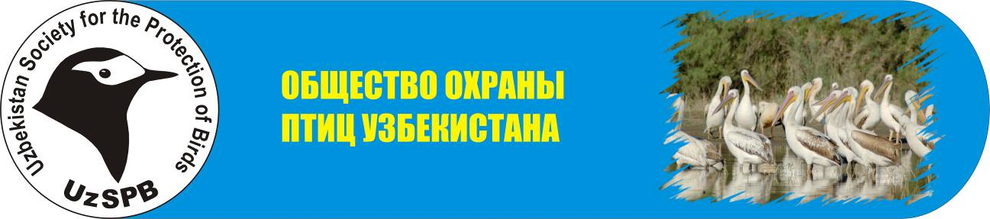
To Executive Directorate
of Uzbekistan Society for the Protection of Birds

from_______________________________

REQUEST

I ask you to affiliate me with Uzbekistan Society for the Protection of Birds (UzSPB). I familiarized myself with Statue of UzSPB.

Signature_________________

UzSPB MEMBERSHIP FORM
FOR ALTERNATE MEMBERS

- Full name __________________________________________________________________
- Date of birth ________________________________________________________________
- Are you parents agree that you will become a member of UzSPB? ______________________
___________________________________________________________________________
- Full name, parents consent, their passport data and sign ______________________________ ___________________________________________________________________________
___________________________________________________________________________
5. Address ____________________________________________________________________
6. Telephone, e-mail ____________________________________________________________
- Place of study________________________________________________________________
- How did you know about UzSPB?________________________________________________
___________________________________________________________________________
- Are you a member of any other club?_____________________________________________
If yes, writ its name___________________________________________________________
- What would you like to do being an alternate member of UzSPB? ______________________
___________________________________________________________________________
___________________________________________________________________________
___________________________________________________________________________
___________________________________________________________________________

Date ______________________

The completed form can be send to UzSPB by post or e-mail: office 89, Institute of Zoology of Uzbekistan Academy of Sciences, A. Niyazov str. 1, Tashkent, Uzbekistan 1000095
e-mail: oleg.kashkarov@iba.uz

